Karcis App Feature

Dynamic event

Register, Login, and Email validation

Post a booking order

Virtual Account Payment

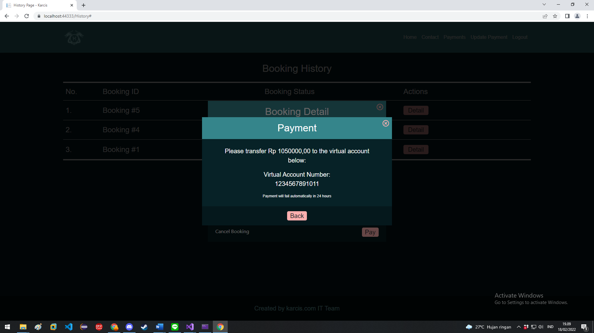

Cancel a booking

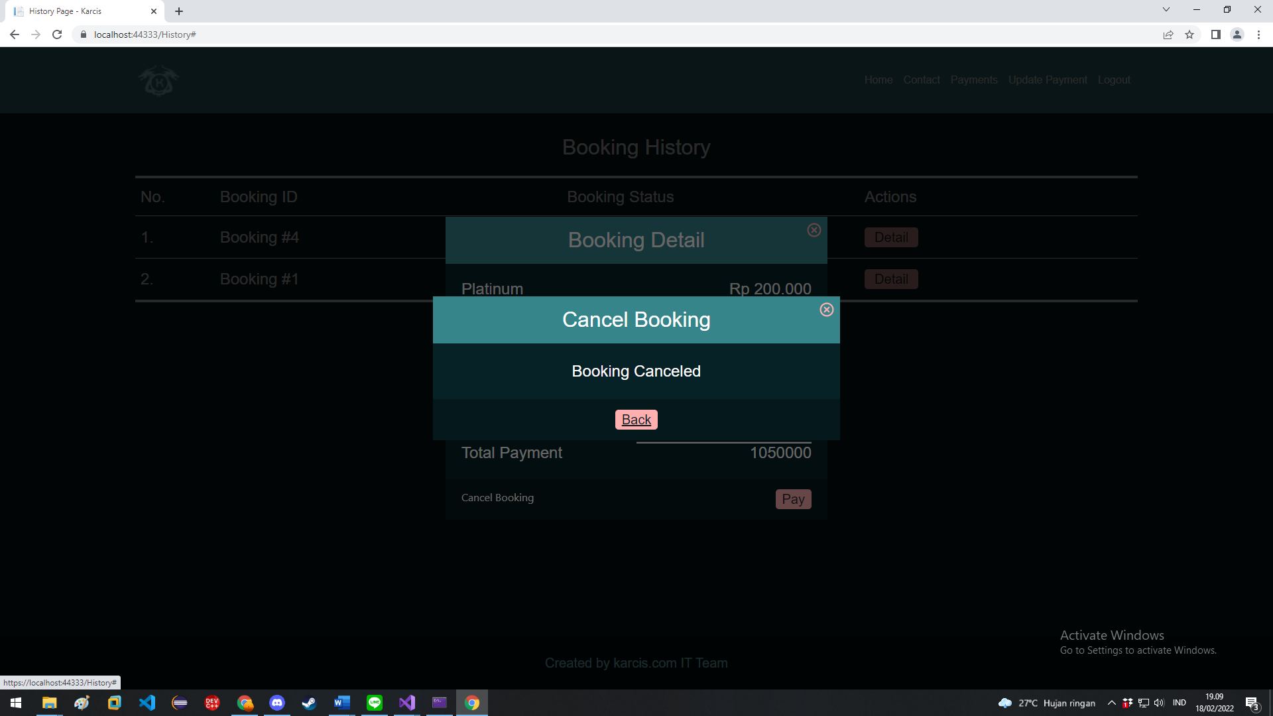

Accept or Decline order via admin role

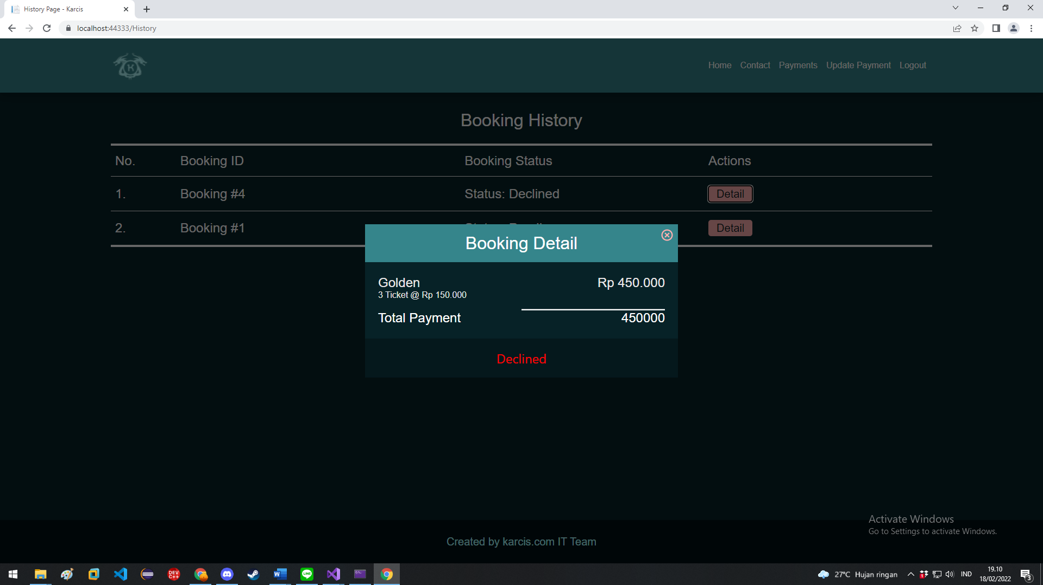

Dokumentasi API App Karcis.com

*skema Database*

**USER**

**REGISTER**

Post register user baru akan di reply dengan code token untuk validasi email, data yang wajib diisi sesuai gambar

**LOGIN**

Request get untuk login

*Akhir dokumentasi User*

**BOOKING**

**SHOW BOOKING HISTORY**

Untuk mendapatkan data booking, bisa menggunakan parameter UserID, jika tidak disediakan dioutput semua

**

**ORDER A BOOKING**

Add booking from body atributny ada UserID, EventName, Tickets(List) { TicketType, Qty }

**ACCEPT PAYMENT BOOKING**

Update status booking from query membutuhkan BookingNumber yang di accept

**CANCEL BOOKING**

Cancel booking mengambil parameter wajib antara TicketID dan BookingID atau 2 2 nya dan wajib ada UserID

*contoh dilanjutkan dari table diatas*

*Akhir dari dokumentasi Booking*

**EVENT**

**GET EVENTS**

Request event yang ada

Parameter current untuk mendapatkan event yang sedang berjalan (bila true hanya ditampilkan yang sedang berjalan)

Parameter keyword untuk pencarian

Dapat di kombinasikan

**CREATE EVENTS** *(Admin privilege)*

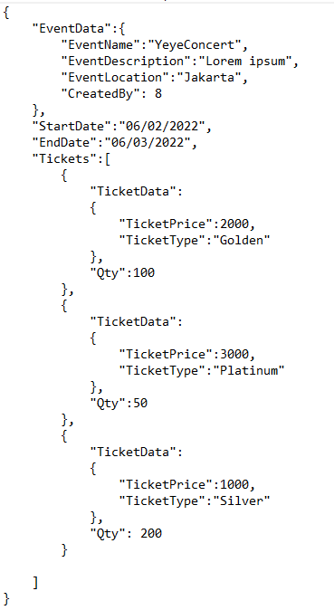Untuk create sebuah event ada beberapa hal yang perlu diinsert dari user ikuti sesuai panduan setiap parameter harus ada dan diisi, untuk Tickets buat TicketData cukup pertype max 4 minimal 0

**UPDATE EVENTS** *(Admin privilege)*

Untuk update bagan mirip dengan insert hanya di bagian CreatedBy diganti UpdatedBy dan perlu ada EventID



**DELETE EVENTS** *(Admin privilege)*

Delete event wajib memberi eventid fromquery



*Akhir dari dokumentasi Event*

**TICKET**

**GET CURRENT AVAILABLE TICKET NUMBER**

untuk mendapatkan jumlah tiket yang sedang **available** untuk parameter EventName wajib disebut, sedangkan TicketType bila kosong akan diambil seluruh jumlah ticket event tersebut

**GET TICKET BOOKING’S TICKET INFOS**

mendapatkan data ticket dengan specific booking tertentu

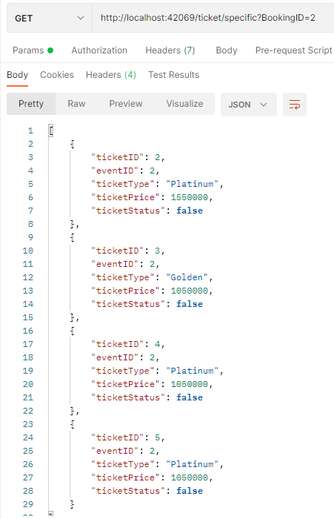

*Akhir dari dokumentasi Ticket*